Faculty of Science, Engineering and Technology

Computer Systems
Week 2

Overview


This laboratory session will be focussed on building a multiplexer and demultiplexer, and connecting them. This should solidify your grasp of truth tables, Boolean expressions and Logisim, as well as giving you an understanding of how computers route information between CPU and memory, etc. You should spend time reviewing the week’s lecture, and watching the tutorial videos.
Purpose:
Building a multiplexer and demultiplexer
Task:
Time:
This lab is due by the start of your week 3 lab.
Assessment:
This lab is worth 1% (up to a maximum of 5%) of your assessment for this unit, and only if demonstrated to your lab demonstrator in the week it is due.
Resources:
■ Week 2 modules on gates and multiplexing

Submission Details
You must submit the following files to Canvas:
■ A document containing all required work as described below.
■ If asked to submit a screenshot of a circuit, submit only one screenshot of that circuit. The screenshot is simply for us to see the wiring, which will not change when you turn pins on and off. We do not need to see s screenshot for every pin combination! ONLY ONE SCREENSHOT FOR EACH CIRCUIT.



Instructions
- Start Logisim and open a new canvas
- We are going to start with the truth table for an 8 way multiplexer. Refer to the 4 way truth table from the lecture material and then extend it. The truth table here shows which address pins should be on or off to correspond to the number of the input we are choosing Include this table in your submission document:
Input | Address pin 1 (A) | Address pin 2 (B) | Address pin 3 (C)
Byte0 | 0 | 0 | 0
Byte1 | 0 | 0 | 1
Byte2 | 0 | 1 | 0
Byte3 | 0 | 1 | 1
Byte4 | 1 | 0 | 0
Byte5 | 1 | 0 | 1
Byte6 | 1 | 1 | 0
Byte7 | 1 | 1 | 1

- Develop Boolean expressions for each line in the table. Again, refer to the examples in the lecture material. Your statements should be in the form used in the lectures, i.e. the inputs to the expression should be A, B, C.
Include this table in your submission document:
Input | Boolean Expression
Byte0 | A’B’C’
Byte1 | A’B’C
Byte2 | A’BC’
Byte3 | A’BC
Byte4 | AB’C’
Byte5 | AB’C
Byte6 | ABC’
Byte7 | ABC

- Open Logisim and complete the 4 way multiplexer shown here.
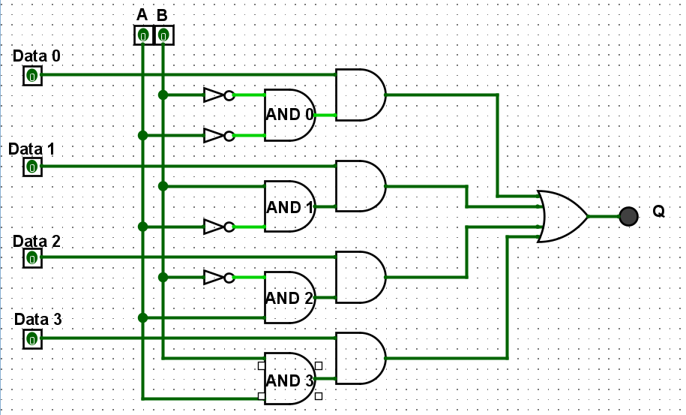
Check its correctness by testing and filling out this table. Add the circuit screen shot (only one) and the table to your submission document:
A |  | B |  | Selected input
 | 1 |  | 0 | Data 2
 | 0 |  | 1 | Data1
 | 1 |  | 1 | Data 3
 | 0 |  | 0 | Data 0

Note that this is an unusual layout for a truth table. Normally you should follow the conventions, but I don’t want you to simply fill out the results from 0-3. I want it to be easier to turn your pins on and check it than to work the correct answer out

- Now you’re going to build an 8 way multiplexer. Before you start, plan it out. Think about the parts you need. For example, you will now have 3 address pins – you’ll need more gates but you will also need to modify the existing gates Discuss it with your tutor if you need to.
(continued on next page)
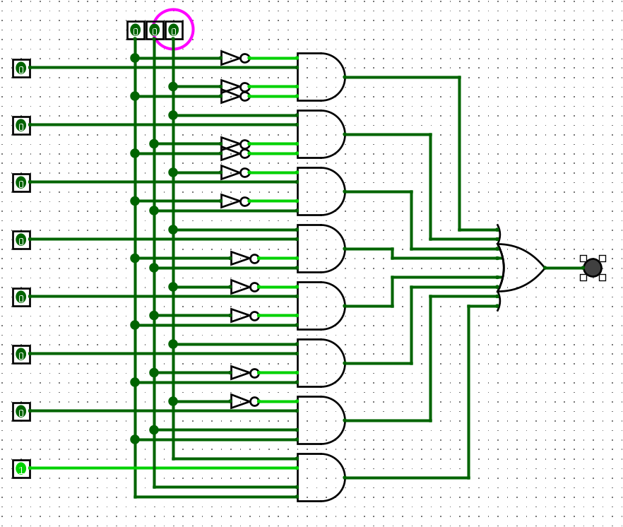

- Build the 8 way multiplexer circuit in Logisim. Test it and complete the following table.
Add the circuit screen shot (only one) and the table to your submission document:
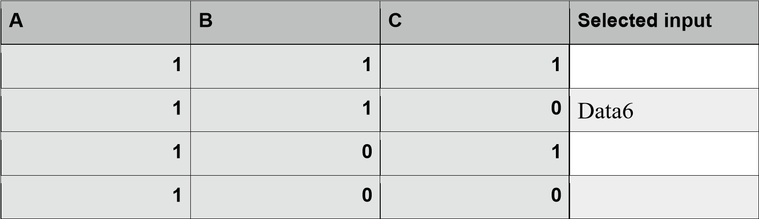
A | B | C | Select input
1 | 1 | 1 | Data 7
1 | 1 | 0 | Data 6
1 | 0 | 1 | Data 5
1 | 0 | 0 | Data 4

- Now build an 8 way De multiplexer in logisim. Again, check the lecture material and extend the 4 way demultiplexer to be an 8 way.
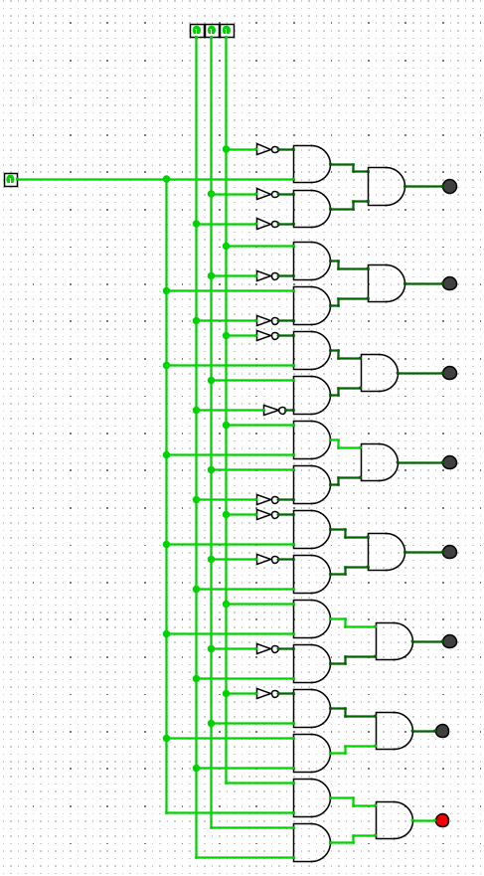
- Finally, connect the multiplexer and the demultiplexer. We’ll get you to submit screenshots of the circuit for 3 tests, because testing all possible combinations is tedious. So for the tests, do the following:
Put your student ID in the submission document. Let’s assume your student ID is 1035866. Firstly, get rid of the “10”. We’re just going to assume you all have “10” there. If you don’t, that’s fine, pretend you have got rid of it. Then, get rid of the numbers greater than 7. So I would be left with 3566 – this is the “final number” I will refer to.

For the first test, connect input1 to the output given by the first digit in that final number So for me, input1 to output3
Then connect input0 to the output for the next digit. For me, input0 to output5

Then connect the next two digits in the final number – the first digit as the input, the second as the output. So for me that’s input6 to output6. Pretty dull. You might also get that lucky. Take a screenshot of each of those tests when you have set the pins and put those 3 screenshots in your submission document.

Student ID: 105029408 => 50240
INPUT | OUTPUT
1 | 5
0 | 0
2 | 4

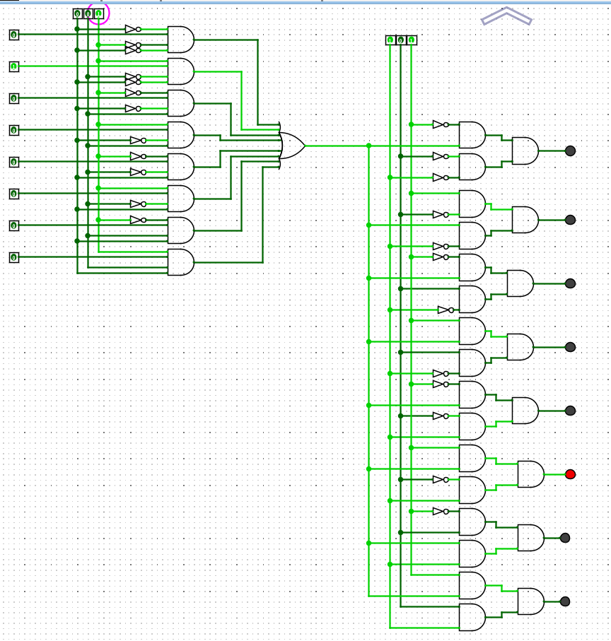
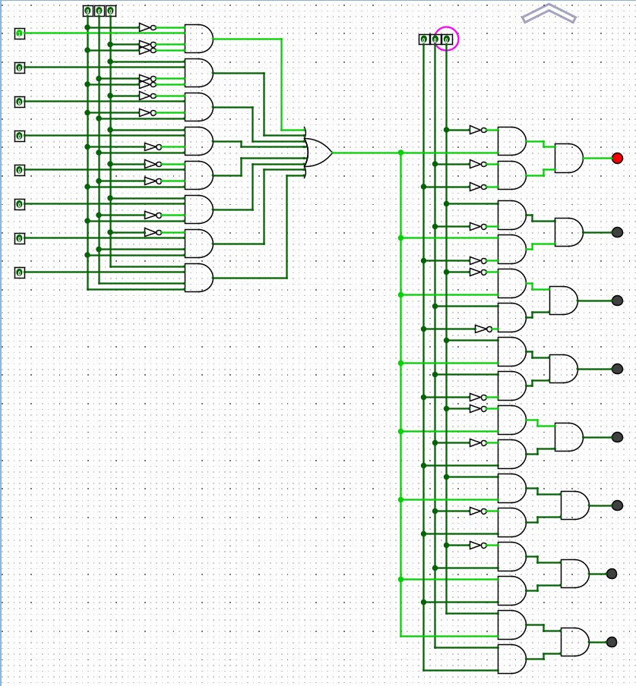
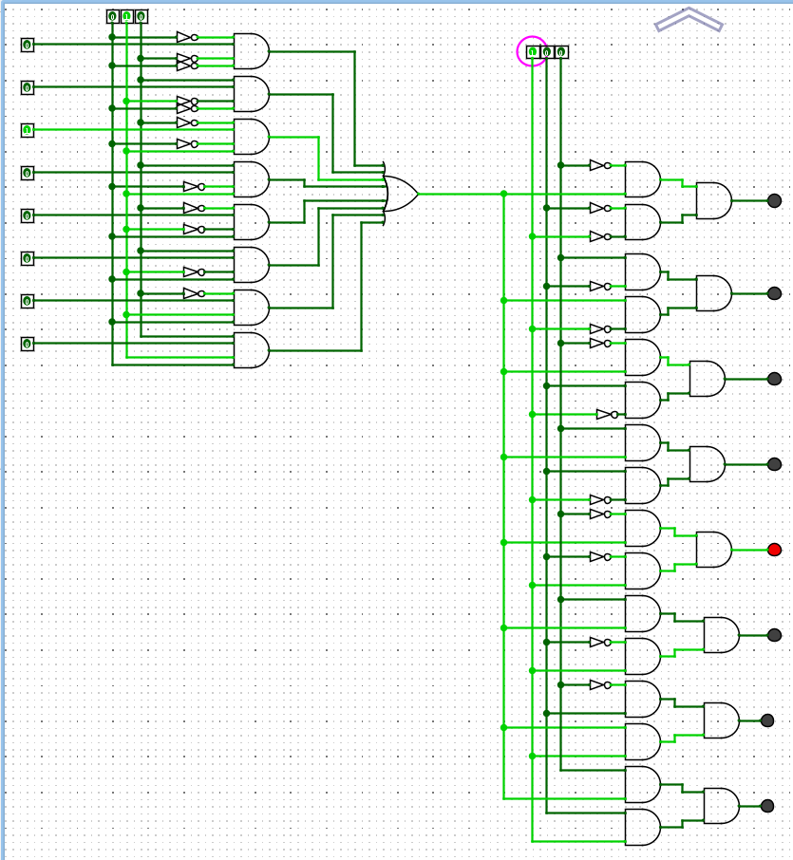

When complete:
■ Submit your answers (screen shots, etc) in a single document using Canvas
■ Show your lab demonstrator your working circuits in class (you must do this to get the 1%).
Your lab demonstrator may request you to resubmit if issues exist.

